Canwegian
Where Canadian Innovation meets Norwegian Tradition
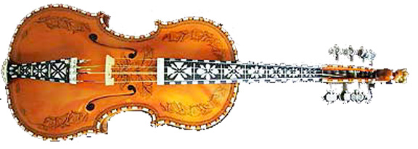
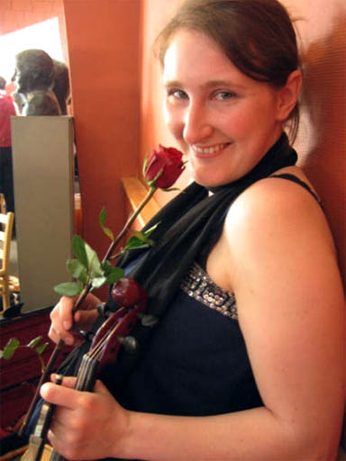
Contemporary adventures in
Nordic culture with 8-string fiddle,
song, and story.

Experienced performance artist Sarah Granskou makes
this exotic Scandinavian music accessible through her humorous, moving stories and songs. She has lived in Norway and Samiland and performs extensively for
all ages.

Sarah Nagell adds her own deep experience of folk traditions, with an emphasis on Hardanger fiddle. She
has studied music in Norway, at St. Olaf College,
and at the New England Conservatory.

Thursday, October 26th
7:00 P.M.
Finlandia University
Finnish American Heritage Center Theatre
435 Quincy Street, Hancock

Tickets by phone or at door
Adults $10, Students $5
Advance purchase, call the Finnish American Heritage Center at 487-7505

Please join us for
Scandinavian refreshments.

The Finnish American
Heritage Center
487-7505
Sons of Norway
Ulseth Lodge 5-670
www.nlc-calumet.org/son
Event Co-Sponsored By:

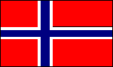

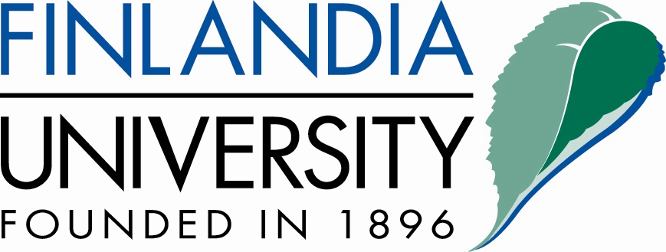
Norwegian-Canadian
Storyteller and Musician

Sarah Granskou
Through intricate patterns of poetic narrative, Sarah tells a simple story. Experienced storyteller and musician, Sarah Granskou is a “Contemporary Canwegian Skald”, having applied her experience of Norwegian oral tradition and imitation to her Canadian sense of innovation. In the Nordic tongue, to “kve” indicates both singing and reciting. While Sarah draws on ancient art forms, her humorous and moving stories are contemporary and relate to her own “adventures” in Canada and Norway, living amongst the Sami and Inuit people, working on farms, building fiddles and simply observing. Sarah’s grandfather Granskou, was president of St. Olaf College, Northfeild, MN. She has performed for all ages at dozens of festivals and hundreds of schools.

Sarah’s first profound musical experience in Norway was amongst the Sami reindeer herders of the North, where she played their exotic wordless singing (“joik”) upon her fiddle. With her great-grandfather’s fiddle in her backpack, Sarah traveled extensively on ski, hut-to-hut in southern Norway. Upon exposure to the music of her ancestry, she immediately responded through what she calls a “genetic memory”. Upon her return, she could have studied at the Norwegian Folk Music Academy, but chose instead an authentic context, working on farms in areas of southern Norway and Sweden. There, she learned from supposedly “inaccessible” masters of singing and Hardanger fiddle and became involved with the people and their music on a personal level.

Sarah Nagell complements Ms. Granskou's talents with her own deep and wide-ranging knowledge of world folk traditions, from bluegrass to Celtic. She has studied voice, both classical and folk, in such unrivaled
institutions as St. Olaf College and the New England
Conservatory. Ms. Nagell recently returned from a year
at the Telemark University College in rural Norway,
where she studied voice and Hardanger fiddle and
competed in both local and national folk music
festivals

